**How to install usb driver ?**

1. In the Configuration folder, replace the firmware in 'fw' with the firmware in usb_driver (windows) folder, named as ‘flicRefApp.mvcmd’, then double-click ‘OpenNCC.exe’ and run the program.
2. Connect the device and check the device manager of the PC.
3. Then click the button ‘Get device info’
4. it shows that the sdriver is not installed now. 
5. Open the driver installer, click the 'Options -> List All Device', then select the VSC Loopback Device.
6. The USB ID will be automatic recognized, choose to install the driver WinUSB and execute ‘Install Driver’.

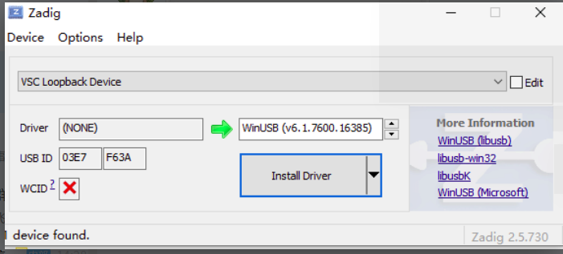

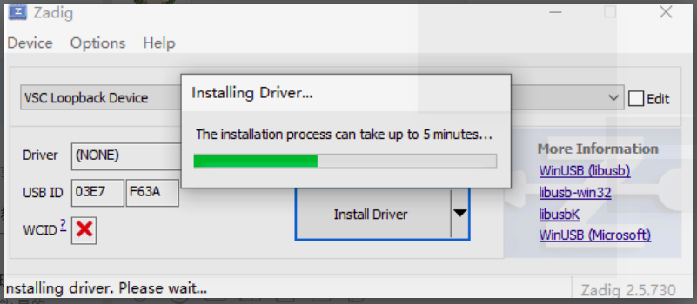

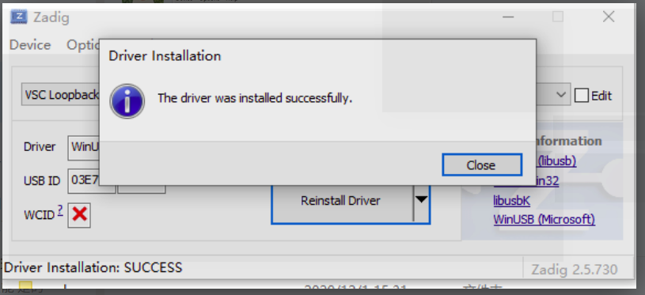

1. Check the device management again, the device driver is installed successfully.



1. Replace the firmware in step 1 and run the openNCC program.
2. After clicking "Get Device Info", if the device cannot be opened, please open the device manager of the computer and confirm the driver status. If the driver is not installed, then re-install the driver to run the device.

**\*\*Note:**

Use Zadig tools may need to disable driver signature enforcement on win10 system and exit antivirus software.